**Kenai Peninsula Chapter of Trout Unlimited Embrace-a-Stream Project: Expanding Knowledge of Fish Habitat in Alaska’s Kenai Peninsula**

*This document has interactive elements, and is best accessed online at* [*https://bookdown.org/kwfwqx/tu_awc_expansion/*](https://bookdown.org/kwfwqx/tu_awc_expansion/)

*Benjamin Meyer, Kenai Watershed Forum (*[*ben@kenaiwatershed.org*](mailto:ben@kenaiwatershed.org)*)*

*2022-11-11*

**Chapter 1 Introduction**

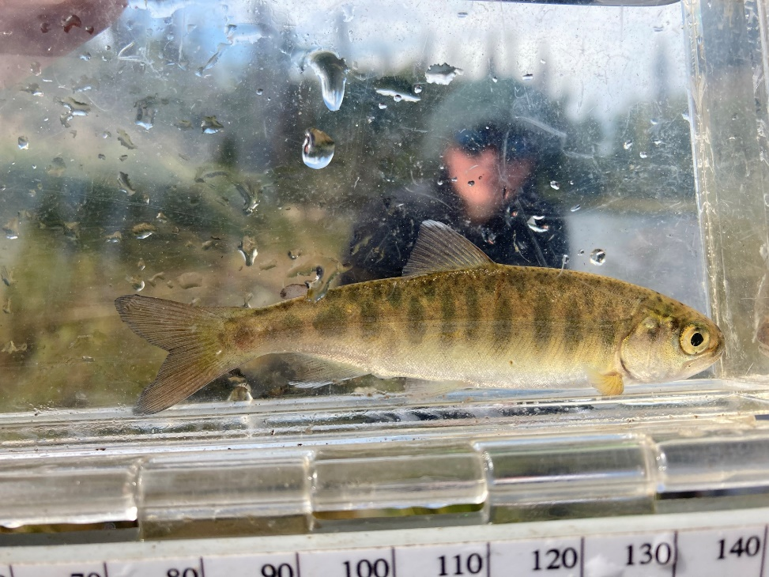

Figure 1.1: Juvenile Coho Salmon

**1.1 Synopsis**

The Kenai Peninsula’s watersheds are significant producers of Pacific salmon. Critical to Alaska’s economic and cultural wellbeing, these salmon support fisheries both inland and throughout Cook Inlet. [The Kenai Peninsula Chapter of Trout Unlimited](https://kenaipeninsula.tu.org/)[1](https://bookdown.org/kwfwqx/tu_awc_expansion/#fn1) (KPTU) in collaboration with [Kenai Watershed Forum](https://kenaiwatershed.org/)[2](https://bookdown.org/kwfwqx/tu_awc_expansion/#fn2) (KWF) are documenting habitat for salmonid spawning, rearing, and migration in order to increase the known water bodies recognized in the Alaska Department of Fish and Game’s (ADF&G’s) Anadromous Waters Catalog (AWC). The AWC is Alaska’s most powerful tool for regulating, protecting, and conserving anadromous fish habitat. Project funding is secured from Trout Unlimited’s [Embrace-a-Stream](https://www.embraceastream.org/)[3](https://bookdown.org/kwfwqx/tu_awc_expansion/#fn3) program as well as the [Kenai Community Foundation](https://www.kenaicommunityfoundation.org/)[4](https://bookdown.org/kwfwqx/tu_awc_expansion/#fn4). This document contains data and analyses reporting results from the project, as well as detailed suggestions on directions of future efforts.

**1.2 Introduction**

Salmon are intrinsic to the cultural and economic well being of Alaska, but cannot persist on the landscape without healthy habitat. Through strategic conservation efforts, riparian and instream habitat can continue to maintain salmon populations as well as transport marine-derived nutrients; maintain hydrology; and provide refuge during a rapidly changing climate. In recognition of the importance of protecting anadromous fish habitat, the State of Alaska enacted [Alaska Statute 16.05.871](http://www.adfg.alaska.gov/index.cfm%3Fadfg=habitatregulations.prohibited)[5](https://bookdown.org/kwfwqx/tu_awc_expansion/#fn5), “Protection of Fish and Game”, which requires the state to list rivers, lakes, and streams important for the spawning, rearing, or migration of anadromous fish, while also requiring the prior approval of construction or use of said waterbody that may result in adverse effects on salmon populations. In response, ADF&G began overseeing the AWC whose data is now publicly hosted online for resource managers and interested members of the public to utilize. See Figure [1.2](https://bookdown.org/kwfwqx/tu_awc_expansion/index.html#fig:awc-map) for ADFG’s online interactive map these data. Access the map at <https://bit.ly/awc_map>.

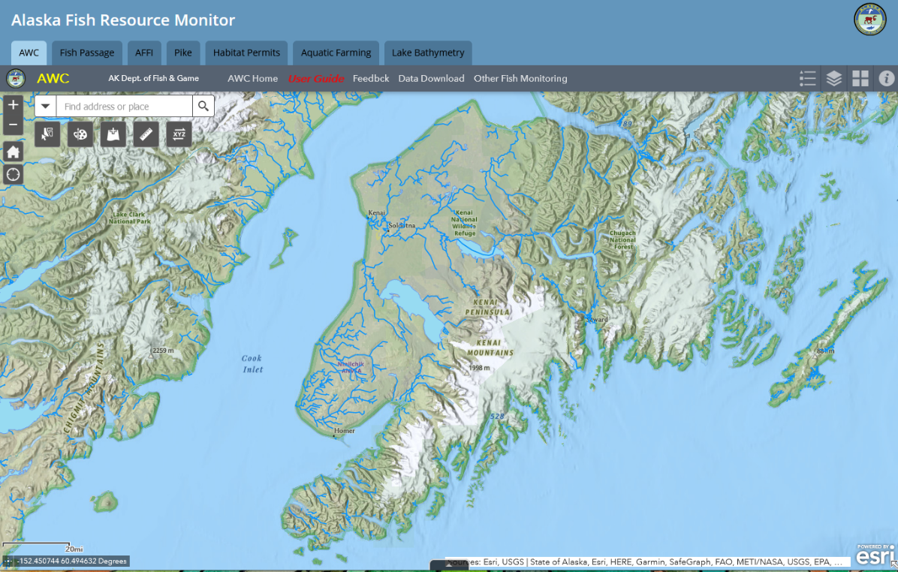

Figure 1.2: Online interactive map of Alaska Department of Fish and Game’s Anadromous Waters Catalog. Access the map at <https://bit.ly/awc_map>.

Each year, ADF&G solicits anadromous stream nominations from statewide efforts from the previous year. Once accepted, these nominations are incorporated into the AWC and its associated atlas. To date, [the AWC includes nearly 20,000 anadromous streams, rivers, and lakes](https://www.adfg.alaska.gov/sf/SARR/AWC/index.cfm?ADFG=main.home)[6](https://bookdown.org/kwfwqx/tu_awc_expansion/#fn6), though it is widely understood that this number represents [less than fifty percent](https://www.adfg.alaska.gov/sf/SARR/AWC/index.cfm?ADFG=nomSubmit.about) of anadromous waterbodies throughout the state[7](https://bookdown.org/kwfwqx/tu_awc_expansion/#fn7). While ADF&G is conducting efforts to update existing data and survey for previously undocumented habitat, there remains a vast number of water bodies in need of surveying and habitat use observations.

In response, Kenai Peninsula Chapter of Trout Unlimited proposed to collect new observations of fish habitat and submit them for inclusion in the AWC. The project is conducted with collaboration from local non-profit [Kenai Watershed Forum](https://kenaiwatershed.org/), which has been conducting annual fish trapping events since 2005, to provide project assistance.

KWF worked with KPTU to strategically prioritize survey sites to collect data for AWC nomination submissions. Site prioritization was based on criteria including the increase in protected anadromous fish habitat, accessibility, and alignment of trapping priorities with local agency and partnership goals. These are described in greater detail in the methods section. KWF coordinated with local agency partners to ensure that trapping efforts were not unnecessarily replicated.

**1.3 Volunteer Training**

On June 5, 2021 a half-day training workshop was conducted by Kenai Watershed Forum staff for fifteen Trout Unlimited volunteers, including but not limited to identifying ideal anadromous fish habitat; responsible deployment and retrieval of minnow traps; juvenile and adult fish identification; data collection and recording while in the field; and safe travel in bear country. Participants were introduced to an [Anadromous Habitat Survey Standard Operating Procedure](https://bit.ly/kwf_awc_sop) (SOP) document[8](https://bookdown.org/kwfwqx/tu_awc_expansion/#fn8).

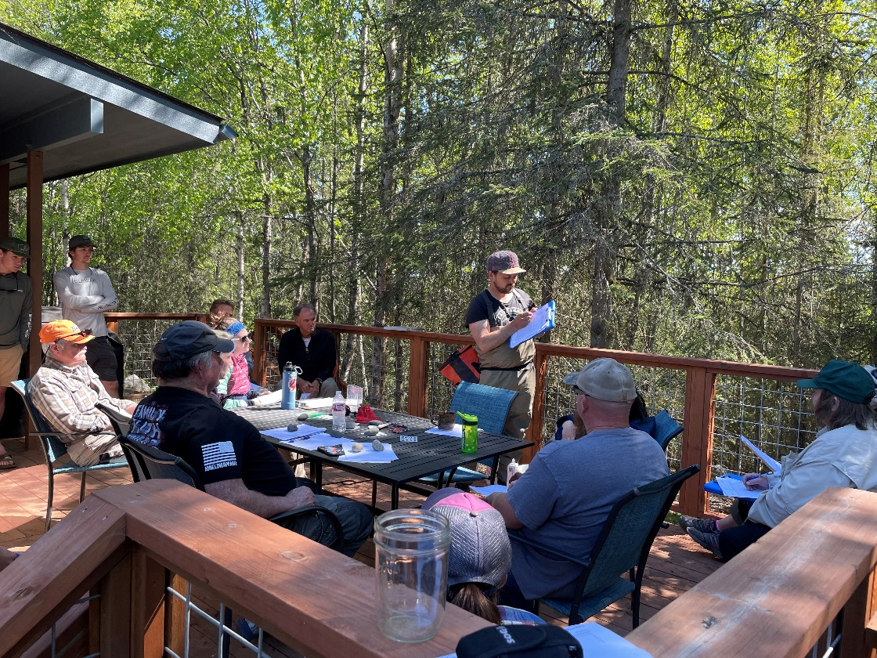

Figure 1.3: Kenai Peninsula Chapter of Trout Unlimited Volunteers.

**1.4 Objectives**

* Submit nominations to increase anadromous stream, river, lake, and wetland coverage in the AWC and corresponding atlas
* Revise or corroborate outdated AWC and atlas data, particularly on Kenai River tributaries experiencing increases in zinc concentrations as well as priority corridors identified by the Kenai Mountains to Sea partnership

*Section 1 Footnotes*

1. <https://www.kenaiwatershed.org>[↩︎](https://bookdown.org/kwfwqx/tu_awc_expansion/index.html#fnref2)
2. <https://www.embraceastream.org/>[↩︎](https://bookdown.org/kwfwqx/tu_awc_expansion/index.html#fnref3)
3. <https://www.kenaicommunityfoundation.org/>[↩︎](https://bookdown.org/kwfwqx/tu_awc_expansion/index.html#fnref4)
4. <http://www.adfg.alaska.gov/index.cfm%3Fadfg=habitatregulations.prohibited>[↩︎](https://bookdown.org/kwfwqx/tu_awc_expansion/index.html#fnref5)
5. <https://www.adfg.alaska.gov/sf/SARR/AWC/index.cfm?ADFG=main.home>[↩︎](https://bookdown.org/kwfwqx/tu_awc_expansion/index.html#fnref6)
6. <https://www.adfg.alaska.gov/sf/SARR/AWC/index.cfm?ADFG=nomSubmit.about>[↩︎](https://bookdown.org/kwfwqx/tu_awc_expansion/index.html#fnref7)
7. <https://bit.ly/kwf_awc_sop>[↩︎](https://bookdown.org/kwfwqx/tu_awc_expansion/index.html#fnref8)

# Chapter 2 Methods

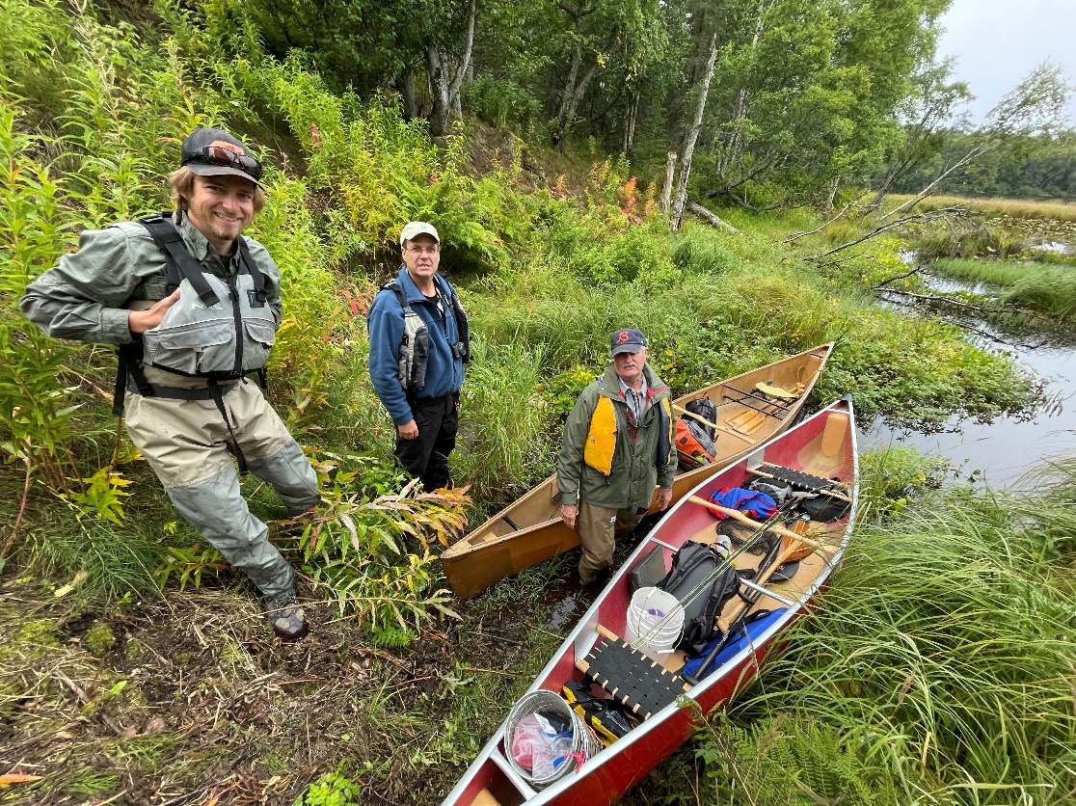

Figure 2.1: Kenai Peninsula Trout Unlimited volunteers preparing for fieldwork at Suneva Lake in August 2021.

## 2.1 Site selection

Fish habitat survey sites were identified using databases generated by Kenai Peninsula Trout Unlimited and Kenai Watershed Forum. Sites were further prioritized using the following criteria:

* Significant increase in protection of anadromous fish habitat through addition of new stream miles/lake acreage
* Ability to provide significant revision and/or data corroboration for outdated catalog data
* Ease of accessibility via foot travel based on travel time and ability to obtain private property access
* Proportion of stream or lake adjacent to developed parcels
* Habitat with medium-high risk assessment rating using the [Kenai Peninsula Fish Habitat Partnership’s “Freshwater Potential Threats Ranking Table](https://www.kenaifishpartnership.org/wp-content/uploads/2013/06/DRAFT-Freshwater-CAP_2014_solicitation.pdf)“[9](https://bookdown.org/kwfwqx/tu_awc_expansion/methods.html#fn9)
* Alignment with trapping priorities of local resource managers as well as partnership efforts including those of Kenai Mountains to Sea (a prioritized corridor list can be found at <https://kenaiwatershed.org/science-inaction/mountains-to-sea/>) and Kenai Peninsula Fish Habitat Partnership (KPFHP)

The project study map may be accessed by following the link at [ArcGIS Online](https://kwf.maps.arcgis.com/apps/webappviewer/index.html?id=ef6e57e2b94c424780b71decf08d50da&extent=-16891358.3246%2C8496162.7219%2C-16658378.2624%2C8619532.0855%2C102100)[10](https://bookdown.org/kwfwqx/tu_awc_expansion/methods.html#fn10) or seen in the figure below. In the online version, click on the symbols in the upper right hand corner to see the legend and layers list. Toggle layers on/off as needed.

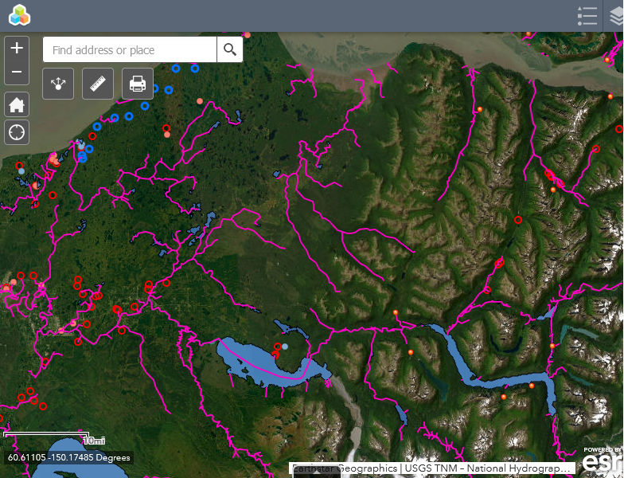

*Map of known anadromous streams in study area along with sample sites suggested by Trout Unlimited (blue) and by Kenai Watershed Forum (red)*

Prior to minnow trap deployment, we obtained all necessary permits from ADF&G including the Aquatic Resource Permit (ARP). As required by the ARP, the ADF&G local Area Management Biologist was notified of trapping locations and timeframes before going into the field. We also obtained landowner permission for access to sites where applicable. Finally, trapping efforts for each day were strategically chosen based on proximity of sites so as to reduce drive and personnel time.

## 2.2 Fish capture and processing

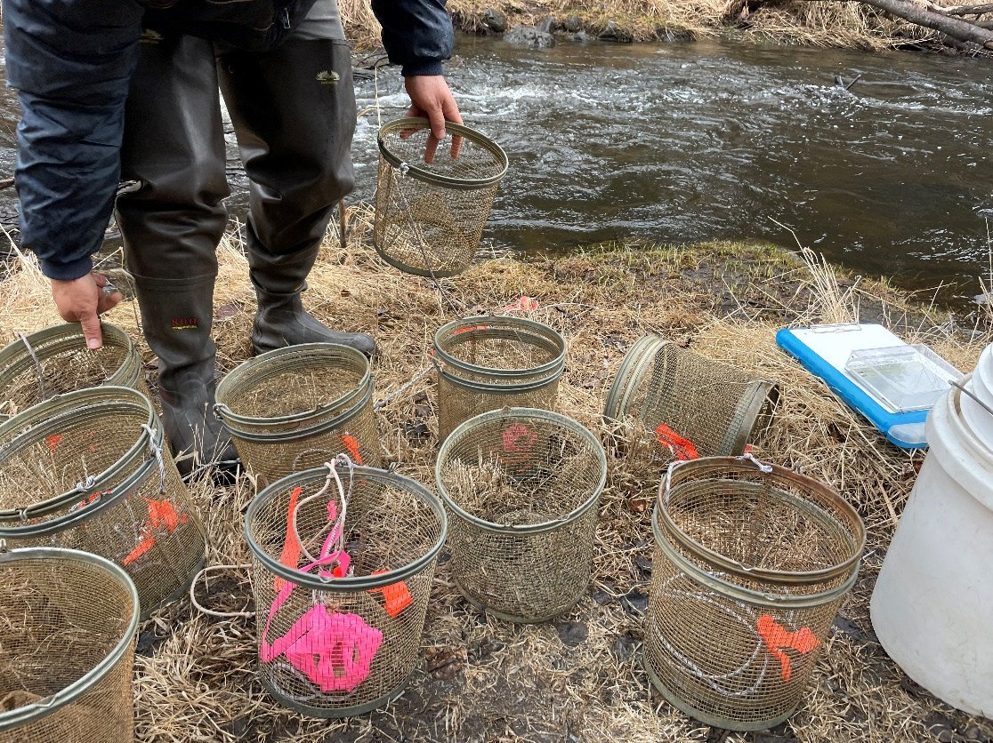

Figure 2.2: Minnow traps being prepared at by Trout Unlimited volunteers at a training workshop at Soldotna Creek in June 2021

### 2.2.1 Minnow Trapping

We used Gee minnow traps (Figure [2.2](https://bookdown.org/kwfwqx/tu_awc_expansion/methods.html#fig:minnow-traps)) baited with salmon eggs as the primary capture methods for juvenile salmonids. We used commercial salmon eggs as bait and placed them in perforated 2-4 oz containers in order to prevent egg consumption by fish. We labeled traps with KWF contact information using brightly colored flagging tape. At the trapping location, we collected site photos and recorded the following on a datasheet: field technician initials, GPS coordinates of trap deployment site(s), and site drawings with pertinent notes regarding fish habitat. We used a minimum of one baited minnow trap, fully submerged in a discrete location, and properly secured to ensure retrieval. We recorded the date and time of deployment. While not exceeding 24 hours, we allowed traps to soak overnight if needed. Upon trap retrieval, we recorded the date and time and transferred the trap’s catch into a bucket of water.

### 2.2.2 Angling

We conducted angling to survey for anadromous fish in habitats such as lakes or large streams and rivers. We employed both traditional spinning rods and fly-fishing techniques. We recorded start and stop time and quantity of anglers.

### 2.2.3 Fish processing

We identified each fish that we captured to lowest feasible taxa and life stage using a photarium. We recorded disposition; and in most cases recorded fork length to the nearest millimeter along with photos of identifying features. When completed, we placed fish in a recovery bucket. Once all fish recuperated successfully, we released them near the original capture location. We monitored data throughout the summer for unintended mortalities, and were prepared to cease sampling and contact the area management biologist should >10% unintended collection mortality occur. We entered all data into the Aquatic Resource Permit spreadsheet provided by the ADF&G and submitted it with a written report to ADF&G at the conclusion of each permit year.

These data were used to submit nominations for the inclusion of new miles or acres of fish habitat to the AWC as well as revision or corroboration of fish presence.

## 2.3 Habitat connectivity

In some cases where maps indicated a likelihood of anadromous habitat yet we did not capture salmonids, we visited additional sites within the drainage where potential barriers to fish passage may exist such as road crossings or modified lake outlets. We photographed and recorded coordinates at these locations if potential fish barriers were apparent and submitted them to ADF&G for potential inclusion in their [Fish Passage database](https://www.adfg.alaska.gov/index.cfm?adfg=fishpassage.database).

## 2.4 Data management and analysis

### 2.4.1 Data management

We recorded data in the field using pre-printed Rite-in-the-Rain field forms, and entered data into a [Google Sheets database](https://bit.ly/eas_data)[11](https://bookdown.org/kwfwqx/tu_awc_expansion/methods.html#fn11). We read data into RStudio and generated this report using the bookdown package (v 0.30). Project edits are managed through a dedicated [project GitHub repository](https://github.com/Kenai-Watershed-Forum/tu_awc_expansion)[12](https://bookdown.org/kwfwqx/tu_awc_expansion/methods.html#fn12).

All project documents and data can be accessed in a dedicated [Google Drive folder](https://bit.ly/tu_kwf_embrace_a_stream_2021)[13](https://bookdown.org/kwfwqx/tu_awc_expansion/methods.html#fn13).

### 2.4.2 Analysis

We generated summary tables displaying the quantity of fish captured at each sample site by date. We also generated a csv file reformatting all fish capture data to prepare for submission to the Alaska Department of Fish and Game to fulfill Aquatic Resource Permit requirements.

*Section 2 Footnotes*

1. <https://www.kenaifishpartnership.org/cap/>[↩︎](https://bookdown.org/kwfwqx/tu_awc_expansion/methods.html#fnref9)
2. <https://arcg.is/01mHjP>[↩︎](https://bookdown.org/kwfwqx/tu_awc_expansion/methods.html#fnref10)
3. <https://bit.ly/eas_data>[↩︎](https://bookdown.org/kwfwqx/tu_awc_expansion/methods.html#fnref11)
4. <https://github.com/Kenai-Watershed-Forum/tu_awc_expansion>[↩︎](https://bookdown.org/kwfwqx/tu_awc_expansion/methods.html#fnref12)
5. <https://bit.ly/tu_kwf_embrace_a_stream_2021>[↩︎](https://bookdown.org/kwfwqx/tu_awc_expansion/methods.html#fnref13)

**Chapter 3 Results**

*Note: All fishing effort and capture results are current as of 2022-11-11.*

**3.1 Fish capture**

During fieldwork in summer 2021 and 2022:

* Over course of 7 fieldwork days in summer 2021 and 2022 (including the training event), KPTU in collaboration with KWF have conducted a total of 12 sampling events at 12 unique sites. See the interactive project map in the Methods section (“[Site selection](https://bookdown.org/kwfwqx/tu_awc_expansion/results.html#id_#%20Site%20selection)”) for a current map of where and when sampling events have occurred.
* Table [3.1](https://bookdown.org/kwfwqx/tu_awc_expansion/results.html#tab:site-visits) summarises total samping events by individual site. We typically sampled a site only one time each.
* We captured 238 fish comprised of 7 unique species. Table [3.2](https://bookdown.org/kwfwqx/tu_awc_expansion/results.html#tab:ct) summarizes fish capture count by species.
* Table [3.3](https://bookdown.org/kwfwqx/tu_awc_expansion/results.html#tab:site-spp-ct) summarizes total fish capture for each species by site.

| **Table 3.1: Total site visits** | |
| --- | --- |
| **site** | **n** |
| Beaver Creek Trib 1.3 | 1 |
| Coal Creek Trib 1 | 1 |
| Funny River Rd Trib 1.1 | 1 |
| Lower Soldotna Creek | 1 |
| Moose River Trib 1.3 | 1 |
| Moose River Trib 1.4 | 1 |
| North Nikiski Lake 1.1 | 1 |
| North Nikiski Lake 1.2 | 1 |
| North Nikiski Lake 2 | 1 |
| soldotna_creek2 | 1 |
| Suneva Lake | 1 |
| Upper Ohmer Lake | 1 |

| **Table 3.2: Total fish capture count by species** | |
| --- | --- |
| **species** | **n** |
| coho salmon | 49 |
| Dolly Varden | 8 |
| rainbow trout | 17 |
| sculpin-unspecified | 2 |
| slimy sculpin | 57 |
| stickleback-unspecified | 56 |
| threespine stickleback | 49 |

| **Table 3.3: Total fish capture count by species at each site** | | | | | | | |
| --- | --- | --- | --- | --- | --- | --- | --- |
| **site** | **coho salmon** | **Dolly Varden** | **rainbow trout** | **sculpin-unspecified** | **slimy sculpin** | **stickleback-unspecified** | **threespine stickleback** |
| Beaver Creek Trib 1.3 | 6 | 0 | 0 | 0 | 0 | 0 | 0 |
| Coal Creek Trib 1 | 6 | 0 | 0 | 2 | 0 | 3 | 0 |
| Funny River Rd Trib 1.1 | 2 | 5 | 0 | 0 | 0 | 0 | 0 |
| Lower Soldotna Creek | 14 | 0 | 11 | 0 | 37 | 0 | 0 |
| Moose River Trib 1.3 | 12 | 1 | 1 | 0 | 0 | 0 | 0 |
| Moose River Trib 1.4 | 5 | 0 | 0 | 0 | 0 | 0 | 0 |
| North Nikiski Lake 1.1 | 2 | 0 | 1 | 0 | 9 | 0 | 0 |
| North Nikiski Lake 1.2 | 2 | 0 | 0 | 0 | 9 | 0 | 49 |
| Upper Ohmer Lake | 0 | 2 | 4 | 0 | 0 | 0 | 0 |
| North Nikiski Lake 2 | 0 | 0 | 0 | 0 | 2 | 8 | 0 |
| soldotna_creek2 | 0 | 0 | 0 | 0 | 0 | 35 | 0 |
| Suneva Lake | 0 | 0 | 0 | 0 | 0 | 10 | 0 |

**3.2 AWC Nominations**

Fish capture data was evaluated against the 2022 Anadromous Waters Catalog to identify new stream segment nominations. Complete submission materials may be accessed in the project [Google Drive folder (link)](https://drive.google.com/drive/folders/1VygMPNtLJvRrKFhdDC77fmSIETm_mmtg?usp=share_link). Nominations were sent to the ADF&G Habitat Division in Anchorage in September 2022.

A total length of **3.51 miles** of stream segments were included in the nominations from fieldwork supported by KPTU activities. Table [3.4](https://bookdown.org/kwfwqx/tu_awc_expansion/results.html#tab:awc-noms) breaks down each nomination by length. Figure [3.1](https://bookdown.org/kwfwqx/tu_awc_expansion/results.html#fig:awc-noms-map) shows our survey sites as well as new nominations.

| **Table 3.4: AWC Nominations** | | |
| --- | --- | --- |
| **Site** | **AWC Nomination Length** | **Unit** |
| Beaver Creek Trib 1.3 | 0.64 | mile |
| Coal Creek Trib 1 | 1.65 | mile |
| Moose River Trib 1 | 0.87 | mile |
| Funny River Rd Trib 1.1 | 0.35 | mile |

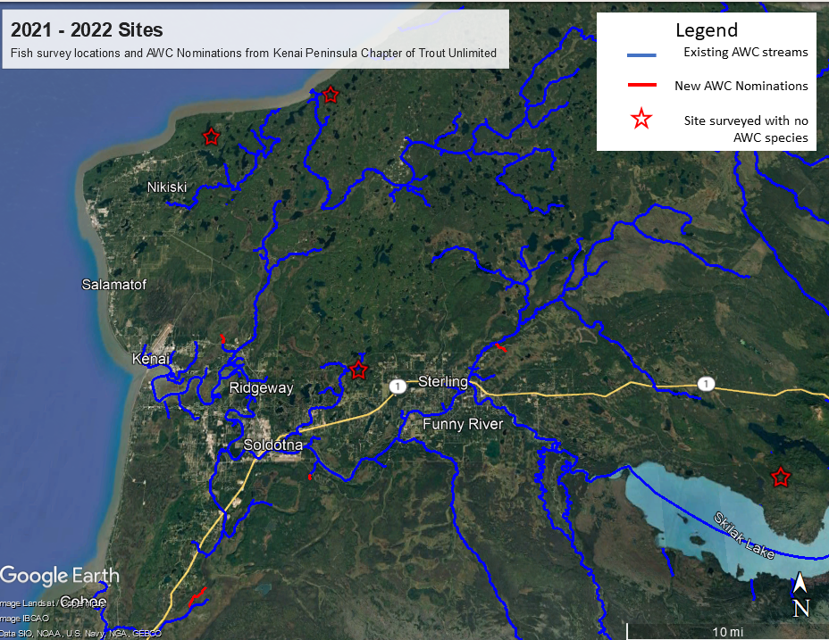

Figure 3.1: Map of AWC nominations.

**3.3 Aquatic Resource Permit**

Fish capture data was reformatted each fall in to a csv file for submission to ADF&G in fulfillment of the required [Aquatic Resource Permit](http://www.adfg.alaska.gov/index.cfm?adfg=otherlicense.aquatic_reports)[14](https://bookdown.org/kwfwqx/tu_awc_expansion/results.html#fn14); available in the online in [this project’s GitHub repo](https://github.com/Kenai-Watershed-Forum/tu_awc_expansion/tree/main/output)[15](https://bookdown.org/kwfwqx/tu_awc_expansion/results.html#fn15).

*Section 3 Footnotes*

1. <http://www.adfg.alaska.gov/index.cfm?adfg=otherlicense.aquatic_reports>[↩︎](https://bookdown.org/kwfwqx/tu_awc_expansion/results.html#fnref14)
2. <https://github.com/Kenai-Watershed-Forum/tu_awc_expansion/tree/main/output>[↩︎](https://bookdown.org/kwfwqx/tu_awc_expansion/results.html#fnref15)

# Chapter 4 Discussion

## 4.1 2021 Fieldwork

### 4.1.1 Anadromous habitat surveys

In summer 2021 we surveyed sites primarily in the region North of Kenai/Soldotna within an hour’s walking distance of the road system.

Survey site selections were made by visually assessing the superimposed map layers of the Anadromous Waters Catalog with the [USGS National Hydrography Database](https://www.usgs.gov/core-science-systems/ngp/national-hydrography) (NHD)[16](https://bookdown.org/kwfwqx/tu_awc_expansion/discussion.html#fn16). In areas where previously documented anadromous stream or lake extents ended but connected water bodies continued upstream, we targeted sites suitable for minnow trapping and/or hook and line survey.

At sites surveyed, we captured primarily non-anadromous species such as stickleback and sculpin. We also captured some resident salmonid species such as Dolly Varden and Rainbow Trout.

These results supported several conclusions that directed fieldwork efforts following summer 2022:

* A need exists to refine methods for survey site selection. Relying on visual assessment of overlay between documented AWC habitat and the NHD map is frequently insufficient as a prospecting guide for yet-unidentified anadromous waters. Discussions in Fall 2021 with personnel at ADF&G’s Habitat Division in Anchorage yielded valuable insight and potential for collaboration.
* Some drainages in the North Kenai/Nikiski area that may have been historically anadromous have man-made barriers to fish passage that we identified in Summer 2021. One such example was previously undocumented as was discovered by TU volunteers, discussed further in the section below, “Highlight: Habitat Connectivity.” Identifying fish passage barrier sites is a critical first step in determining if restoration is feasible.

#### 4.1.1.1 Highlight: Habitat Connectivity

In one case where map interpretation suggested presence of salmonids but we captured none, we visited other locations in the watershed where fish barriers may be present. We found evidence of man-made fish barriers:

* Suneva Lake - Suneva Lake lies to the North of Daniels Lake in the Nikiski area. The lake’s surface area is appx 6.0 sq km, and flows directly in to Cook Inlet 0.61 km downstream from the lake outlet. Aerial imagery indicates that littoral is ~95% undeveloped. Littoral parcels are primarily privately owned.

We conducted extensive sampling on Suneva lake, using minnow traps as well as angling. We captured stickleback and sculpin, but no salmonids despite extensive effort.

We visited the outlet at Suneva lake and discovered two perched culverts installed where the outlet stream crosses Sockeye Avenue (see figure [4.1](https://bookdown.org/kwfwqx/tu_awc_expansion/discussion.html#fig:suneva-outlet). The culvert is likely impeding fish passage (assuming no additional downstream barriers), as there is a drop of several feet between the stream channel and the culvert outlet.

A site visit to the mouth of the creek flowing from Suneva Lake at its outlet at Cook Inlet will help determine if the waterway has potential to host anadromous species and may be part of future fieldwork.

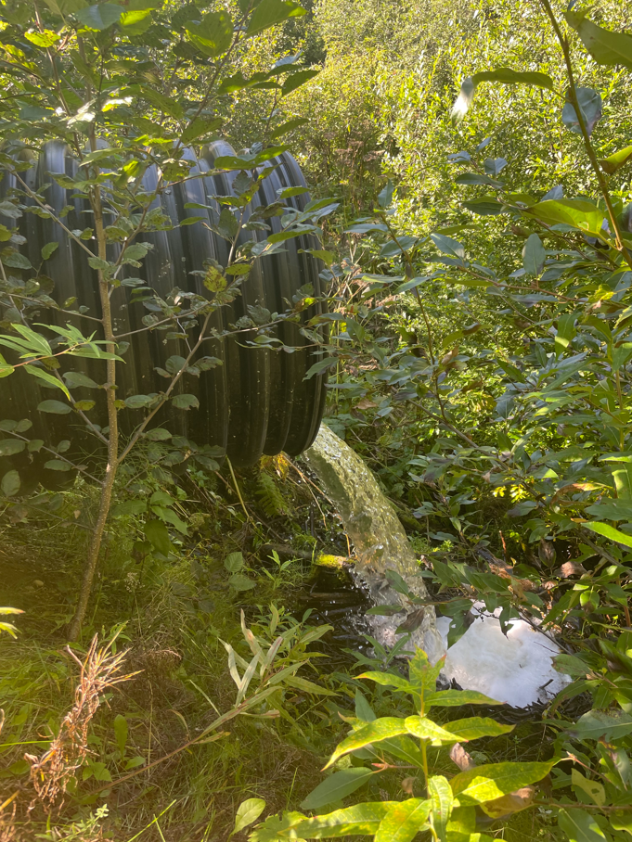

Figure 4.1: Perched culvert near outlet of Suneva Lake, intersection with Sockeye Avenue

## 4.2 2022 Fieldwork

In Summer 2022 we focused our survey efforts on streams in the Kenai/Soldotna/Sterling area including Coal Creek, Beaver Creek, and tributaries of the Moose River. Experience from the previous season contributed to much more frequent success of identifying anadromous habitat prior to fieldwork. **In 2022, four out of five site visits yielded fish observations used in AWC nominations.**

In one case, at the “Moose River Trib 1.4” site, the flow line indicated by the National Hydrography Database stops ~0.3 miles downstream of the location where we captured juvenile coho salmon. Thus, this salmon-bearing location was not only not documented in the Anadromous Waters Catalog, it was not documented as a stream.

These observations highlight the need for a more sophisticated mapping approach to generate survey sites for additional fieldwork. For additional discussion and a plan forward on this topic, see the “Next Steps” chapter.

## 4.3 Media highlights

KDLL Public Radio joined one group of volunteers on August 27, 2022 and released a four-minute story on September 2, 2022. The story also reached state-wide audiences on Alaska News Nightly. See Figure [4.2](https://bookdown.org/kwfwqx/tu_awc_expansion/discussion.html#fig:radio-story) for the story.

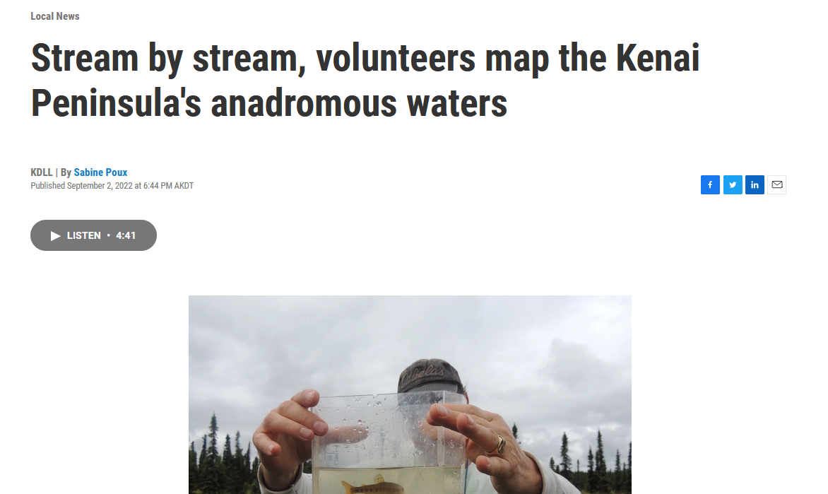

Figure 4.2: KDLL Public Radio story on September 2, 2022. Read and listen to the story at <https://www.kdll.org/local-news/2022-09-02/stream-by-stream-volunteers-map-the-kenai-peninsulas-anadromous-waters>

*Section 4 Footnotes*

1. <https://www.usgs.gov/core-science-systems/ngp/national-hydrography>[↩︎](https://bookdown.org/kwfwqx/tu_awc_expansion/discussion.html#fnref16)

**Chapter 5 Future Directions**

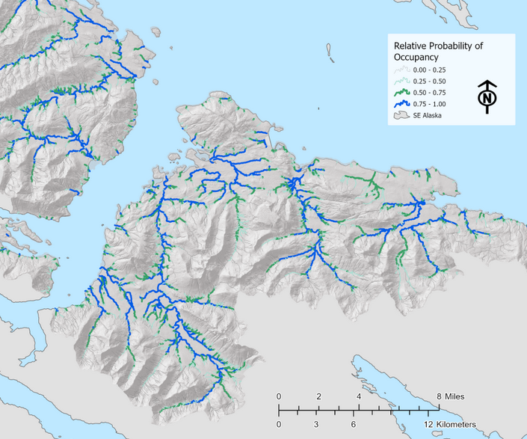

Figure 5.1: Figure from ‘Southeast Alaska Fish Habitat,’ Romey Fisheries and Aquatic Sciences 2021.

The collaboration between the Kenai Peninsula Chapter of Trout Unlimited and Kenai Watershed Forum serves as a compelling example of how to engage volunteers interested in conserving fish habitat with hands-on opportunities. There is great potential to expand and continue the work described in this report, and a great urgency to do so.

The Anadromous Waters nominations generated as a result of this project will play an important role in conserving salmon habitat in the areas we surveyed. The value of educating and engaging volunteer participants is also evident. However in a broader view, the primary take away from this project is highlighting the need to re-frame our long term approach for how to discover, document, and conserve anadromous habitat. Our current methods would continue to yield additional AWC nominations, but at a scale insufficient to keep pace with the need to identify salmon streams in the path of new developments. The potential to accelerate this work and document hundreds of additional anadromous stream miles on the Kenai Peninsula is ready at hand, and much of the initial groundwork has already been completed and is awaiting financial support.

**5.1 Rationale for Anadromous Waters Mapping in Alaska**

As described in Section 1.2 of this report, current Alaska statute is such that rivers, streams, and lakes throughout Alaska are presumed non-anadromous until otherwise demonstrated, thus the need for the hands-on documentation such as that featured in this project. A failed statewide ballot measure initiative in 2018 would have reversed the baseline presumption of non-anadromy, among other changes to salmon habitat regulations[17](https://bookdown.org/kwfwqx/tu_awc_expansion/future-directions.html#fn17).

Various state, federal, tribal, private, and non-profit entities have pursued the work of documenting anadromous habitat for decades and contributed to the detail contained within the anadramous waters catalog. Even so, tens of thousands of miles of salmon habitat remain undocumented, including in areas adjacent to developing urban communities. When anadromous habitat is undocumented, proposed development on or near these waters will not trigger the need for a Fish Habitat Permit review from ADF&G, which requires impacts to be evaluated along with possible mitigation requirements such as fish-friendly culverts or enforcement of riparian buffer zones.

This dearth of detailed map information has had consequences particularly in rapidly developing areas. For example, in Summer 2021 a tributary Soldotna Creek was partially excavated and ditched, and was not documented as anadromous until after the fact[18](https://bookdown.org/kwfwqx/tu_awc_expansion/future-directions.html#fn18). Another prominent example is when in 2008-2010, dozens of anadromous streams were documented and nominated by The Nature Conservancy directly within the proposed footprint of Pebble Mine; waters that had not been documented by mine consultants conducting baseline assessments[19](https://bookdown.org/kwfwqx/tu_awc_expansion/future-directions.html#fn19),[20](https://bookdown.org/kwfwqx/tu_awc_expansion/future-directions.html#fn20). Thus the sooner that currently undocumented anadromous waters are documented, the more likely it is that impacts can be properly evaluated and mitigated prior to development.

**5.2 Current State of Anadromous Waters Mapping**

As described in section 2.1 of this report (Methods: Site Selection), most current fieldwork efforts are prioritized by visually assessing the overlap of stream segments in the Anadromous Waters Catalog and the National Hydrography Database. Communication among regional researchers and managers also helps choose fish survey locations, along with suggestions from the general pubic. Researchers have also used formal oral interviews with traditional knowledge holders to help suggest fish survey locations[21](https://bookdown.org/kwfwqx/tu_awc_expansion/future-directions.html#fn21).

While all these methods are useful in generating ideas for survey locations, they do not comprise a systematic approach and they are based on incomplete stream network maps. In order for conservation needs to better match the pace of conservation challenges, a more comprehensive approach is needed. In the southern Kenai Peninsula, researchers with Kachemak Bay National Estuarine Research Reserve (KBNERR) successfully applied just such an approach during a study from 2012 ([King et al. 2012](https://www.journals.uchicago.edu/doi/abs/10.1899/11-109.1))[22](https://bookdown.org/kwfwqx/tu_awc_expansion/future-directions.html#fn22) and added dozens of miles to the AWC from resulting efforts. However, the approach taken by the KBNERR researchers would arguably prove challenging to replicate at broader geographic scales, as it relies on extensive ground truthing of habitat characteristics and flow to produce the predictive model.s

Another similar approach to anadromous habitat mapping is currently being applied in southeast Alaska by the U.S. Forest Service and other partners. Using high resolution stream network maps coupled with fish habitat intrinsic potential models, researchers are able to predict the locations of upper extent of anadromy with 98% accuracy with an average error distance of < 67m[23](https://bookdown.org/kwfwqx/tu_awc_expansion/future-directions.html#fn23). For more details see the [StoryMap from Romey Fisheries and Aquatic Sciences](https://storymaps.arcgis.com/stories/6b3949e1ebcd44c6a531d13f038807c5)[24](https://bookdown.org/kwfwqx/tu_awc_expansion/future-directions.html#fn24).

Predicting the locations of upper anadromous extent allows researchers to take a more informed approach to prioritzing their fieldwork of documenting anadromous habitat. Researchers in southcentral Alaska should aspire to emulate the approach described in the preceding StoryMap, focusing particularly on waters outside federally protected areas.

For future long-term efforts to effectively gather field data to be used in AWC nominations, two general research directions are suggested:

1. Application of higher-resolution stream network maps and habitat modeling approaches, such as [NetMap](https://www.fs.usda.gov/pnw/tools/netmap)[25](https://bookdown.org/kwfwqx/tu_awc_expansion/future-directions.html#fn25)
2. Evaluation of “success rates” in prospecting for anadromous sites. E.g., how frequently, when, and where do predictions undocumented anadromous habitat prove correct?
3. Formal and frequent communication and collaboration among entities conducting anadromous habitat survey work

The combination of these approaches outlines a collaborative “ground-truthing” type approach to AWC mapping, where remote sensing data is used to make predictions that are then refined by field observations. Given the near-perfect rate of predictions thus far using this approach, in the future these maps of stream segments *predicted* to be anadromous might be used by managers when evaluating environmental impacts and the need for permitting and mitigation – pending continued public education and support and acceptance by regulators.

**5.3 Next Steps**

To follow though on the recommendations above, a dedicated research project should be developed and executed in collaboration with subject experts. The following steps describe a path forward:

1. **Commission NetMap coverage for the Kenai Peninsula Borough**
   * This task is already partially complete. NetMap was commissioned for the Chugach National Forest in 2017, and Kenai Peninsula coverage extends from Prince William Sound / Turnagain Arm region to the western boundary with Kenai National Wildlife Refuge. The shapefiles are available by contacting Kenai Watershed Forum or Romey Fisheries and Aquatic Sciences.
   * LiDAR, a geospatial dataset needed to produce the NetMap stream layers, has complete coverage for the Kenai Peninsula Borough region.
   * A quote for estimated cost was provided to Kenai Watershed Forum from TerrainWorks in Fall 2022.
2. **Develop, communicate, and maintain a prioritized list of fish habitat survey sites shared among multiple agencies**
   * Once a list of locations of predicted Upper Extent of Anadromy is generated using the NetMap layer, regional experts can use their knowledge of local conservation priorities to prioritize which sites should be surveyed first. This step will involve both a GIS based approach for tasks such as identifying parcel ownership status where sites are located, as well as a consensus/discussion based approach to apply knowledge of local conservation priorities and planning efforts.
   * Site survey responsibilities will be assigned to participating organizations. Once complete, preliminary results will be recorded in a shared database to minimize redundant site visits.
3. **Recruit and train participants from agency employees and volunteers**
   * Entities known to currently be engaged in the work of AWC nominations in the Kenai Peninsula region include the following, but are not limited to:
     + Alaska Department of Fish and Game Habitat Division
     + Kenai Soil and Water Conservation District
     + U.S. Fish and Wildlife Service
     + Kenai Watershed Forum
     + Kachemak Bay National Estuarine Research Reserve
     + Kenai Peninsula Chapter of Trout Unlimited
     + University of Alaska
     + Tyonek Tribal Conservation District
   * Training sessions would be offered to encourage participation from the general public
   * Employing a user-friendly, seamless method of data collection will be critical to implementing this project on a larger scale. ADF&G requires that AWC nominations are supervised by a “qualified biologist,” thus careful and systematic review of nomination data prior to submission will be essential. Use of a custom-designed ESRI Survey123 app is likely the most appropriate choice for this task. The smartphone app “[Fish Map App](https://alaskafishmapping.org/)[26](https://bookdown.org/kwfwqx/tu_awc_expansion/future-directions.html#fn26)” developed by the Indiginous Sentinals Network also shows potential to be highly useful in this process; though currently the app is not designed to record some essential information such as gear effort.
   * A high degree of location accuracy (<1m) is required for ground-truthing NetMap data. Expensive options such as Trimble hand held devices may be inaccessible, thus it is suggested to train participants to use bluetooth accessory receivers (e.g. [Bad Elf GNSS Surveyor](https://bad-elf.com/pages/be-gps-3300-detail)) when recording coordinates.

A suggested initial approach is to use the already-existing NetMap layer covering the Chugach National Forest region in the process described above. Pending successful results and AWC nominations, the project as described above should be commissioned and executed at the scale of the entire Kenai Peninsula Borough region. Many other regions of Alaska have already had synthetic stream networks developed and mapped. Following the success of the work proposed above, the approach would be able to be replicated state-wide.

**5.4 Final Words**

While this report shows how much has been accomplished in documenting local salmon habitat, it is clearer than ever how much remains to be accomplished. We are grateful for the help and support of the dozens of volunteers involved with making this project happen and we look forward to continuing our efforts together.

*Section 5 Footnotes*

1. <https://ballotpedia.org/Alaska_Ballot_Measure_1,_Salmon_Habitat_Protections_and_Permits_Initiative_(2018)>[↩︎](https://bookdown.org/kwfwqx/tu_awc_expansion/future-directions.html#fnref17)
2. <https://bookdown.org/kwfwqx/awc_expansion/discussion.html#highlight-soldotna-creek-tributary>[↩︎](https://bookdown.org/kwfwqx/tu_awc_expansion/future-directions.html#fnref18)
3. <http://www.pebblescience.org/pdfs/FishSurveysinNushagak%20and%20Kvichakheadwaters.pdf>[↩︎](https://bookdown.org/kwfwqx/tu_awc_expansion/future-directions.html#fnref19)
4. <https://www.adn.com/alaska-news/article/salmon-documented-streams-top-pebble-prospect/2011/04/27/>[↩︎](https://bookdown.org/kwfwqx/tu_awc_expansion/future-directions.html#fnref20)
5. Personal communication with Duncan Green, Alaska Department of Fish and Game, February 21, 2022[↩︎](https://bookdown.org/kwfwqx/tu_awc_expansion/future-directions.html#fnref21)
6. <https://www.journals.uchicago.edu/doi/abs/10.1899/11-109.1>[↩︎](https://bookdown.org/kwfwqx/tu_awc_expansion/future-directions.html#fnref22)
7. <https://paperpile.com/app/p/e21bfd9e-9b5a-0237-ad38-12b73fbdccbb>[↩︎](https://bookdown.org/kwfwqx/tu_awc_expansion/future-directions.html#fnref23)
8. <https://storymaps.arcgis.com/stories/6b3949e1ebcd44c6a531d13f038807c5>[↩︎](https://bookdown.org/kwfwqx/tu_awc_expansion/future-directions.html#fnref24)
9. <https://www.fs.usda.gov/pnw/tools/netmap>[↩︎](https://bookdown.org/kwfwqx/tu_awc_expansion/future-directions.html#fnref25)
10. <https://alaskafishmapping.org/>[↩︎](https://bookdown.org/kwfwqx/tu_awc_expansion/future-directions.html#fnref26)